To set up the database used in this project, follow these steps (for Windows):

* Install MySQL Server 5.5.
  + You can download that bad boy right here: <https://dev.mysql.com/downloads/mysql/5.5.html>
  + Configure it following the steps provided in the installer.
* After installing it, use the root account and password that you configured to access your database.
  + In Command Prompt, go to the ‘MySQL Sever 5.5’ folder on your computer.
    - Mine was located under Program Files\MySQL\MySQL Server 5.5\
  + Go to the bin folder within the current directory, and start MySQL.
    - “mysql -u root -p”
    - It will prompt you for your root password, type that, and you should be granded access to your MySQL instance!
* Create your database! I realize that it is ironic that I’m using a database in a blockchain project, but this is being used to authenticate users of our “wallet service”.
  + First, create the database itself (a source I often referred to whenever I forgot how to do this was the following: <https://www.a2hosting.com/kb/developer-corner/mysql/managing-mysql-databases-and-users-from-the-command-line>!)
    - “CREATE DATABASE <database>;”
  + Now, you’ll want to create a table of users.
    - Start using the database you just created.
      * “USE <database>;”
    - Now, create your table. This is going to just include 3 columns: a username, a password, and a hash. The username and password are used by the service/wallet that we created, to access how many coins a given user might have. That being said, the actual recipients and all in the blockchain itself are stored as hashes. So, when loading all the coins that one user has and all relevant transactions, it maps the given username and password to that hash, and includes the transaction.
      * “CREATE TABLE users (username VARCHAR(255), password VARCHAR(255), hash VARCHAR(255))”;
* Create a user for your Node.js server to use when interacting with the database.
  + First, you want to make sure that you are in the right database to add users.
  + “USE mysql;”. now you will be able to modify the user table.
    - You can verify the “user” table’s existence (and that it is called “user”, not “users”) by simply typing “SHOW tables;”.
    - If you want to see all the users in your table, you can type “SELECT \* FROM user;”
  + Add a new user.
    - “CREATE USER ‘<username>’@’<address>’ IDENTIFIED BY ‘<password>’;”
      * If your Node.js instance is running on a machine that ISN’T the same one that your MySQL instance is running on, then put that address in for <address>. Otherwise, you can just type ‘localhost’!
  + Now, you’ll want to give it permissions. We are just going to give this permissions to update, insert into, and select from the users table, within the database you just created. If you want to give your new user other permissions, you can find other options here: <https://kyup.com/tutorials/create-new-user-grant-permissions-mysql/>
    - “GRANT SELECT, INSERT, UPDATE ON <database>.users TO ‘<username>’@’<address>’;”
* Awesome! Now, you’’ just want to update your BlockChainTest\server\index.js file to reflect these changes.
  + 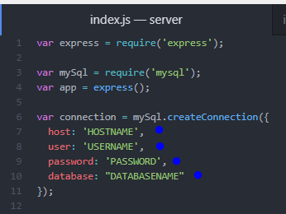
  + Change the host to reflect your host address, or whatever you entered for <address>
  + Change the username, password, and database accordingly as well, to <username>, <password>, and <database>, respectively.